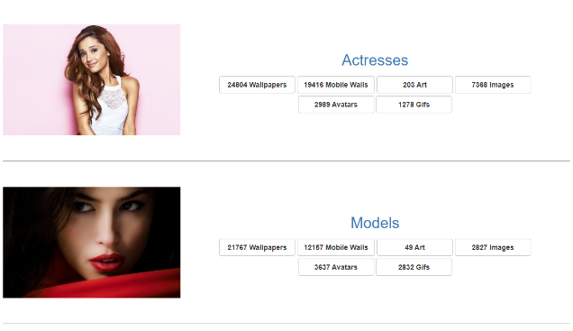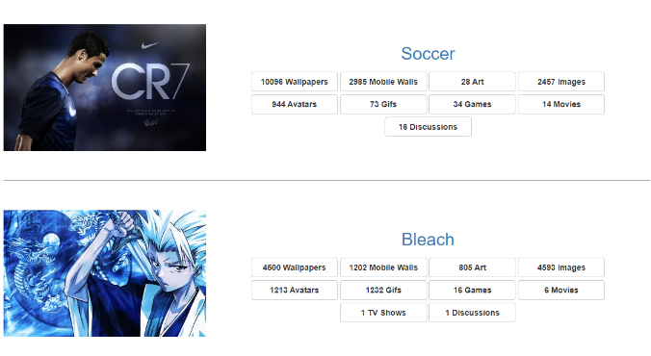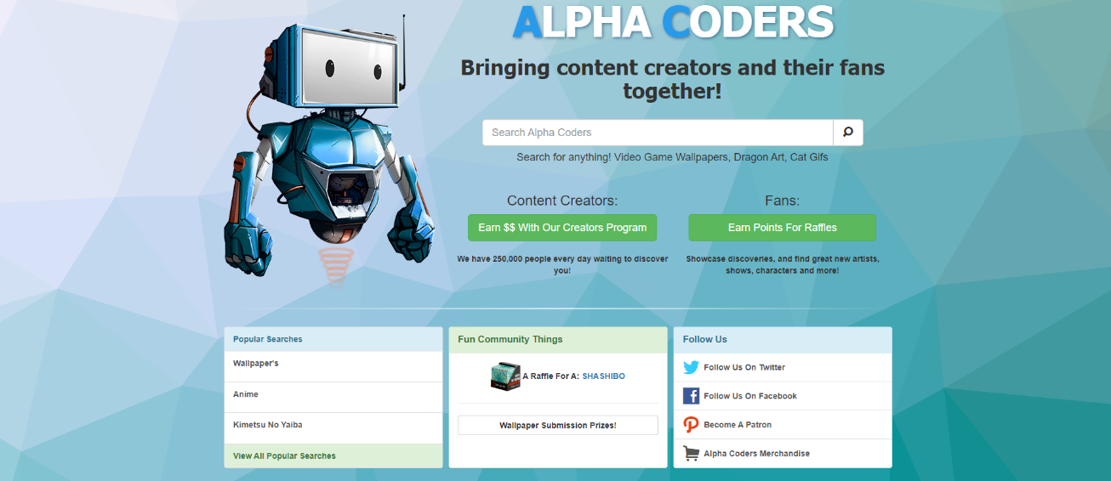

[AlphaCoders.com](https://alphacoders.com/) is a platform that connects content writers with their fans to collaborate for great revenue earning opportunities. Through this platform, you can search images, avatars, art and much more as content.

A platform built using the Laravel framework, AlphaCoders.com is expanding worldwide, and credit goes to its uniqueness.

In this project, I develop card designs by Laravel framework.